ASSIGNMENT # 1 WEB ENGINEERING  
IMRAN KHAN   
BSE 7B   
46108

**Q.1 Visit some good sites and give a brief view about the architecture of website with some diagrammatic examples**

**GOOGLE:**

### How does Google crawl the web content?

Running a web crawler is a challenging task. Crawling is the most fragile application since it involves interacting with hundreds of thousands of web servers and various name servers which are all beyond the control of the system.

To scale to millions of web pages, Google has a fast distributed crawling system. A single URLserver serves lists of URLs to a number of crawlers. Each crawler keeps roughly 300 connections open at once. It works on a simple iterative algorithm. This algorithm differs with the search engines as well as the kind of query. This is necessary to retrieve web pages at a fast enough pace. This factor makes the crawler a complex component of the system.(Refer fig)

This means running a crawler which connects to more than half a million servers and generates tens of millions of log entries. Because of the immense variation in web pages and servers, it is virtually impossible to test a crawler without running it on a large part of the Internet.

### The Google Ranking System:

Google maintains much more information about web documents than typical search engines. Every hit list includes position, font, and capitalization information. Combining all of this information into a rank is difficult.

First, consider the simplest case — a single word query. In order to rank a document with a single word query, Google looks at that document’s hit list for that word. Google counts the number of hits of each type on the hit list. Then it computes an IR score for the document. Finally, the IR score is combined with PageRank to give a final rank to the document.

For a multi-word search, the situation is more complicated. Now multiple hit lists must be scanned through at once so that hits occurring close together in a document are weighted higher than hits occurring far apart. For every matched set of hits, proximity is computed. Counts are computed not only for every type of hit but for every type and proximity. Thus it computes an IR score.

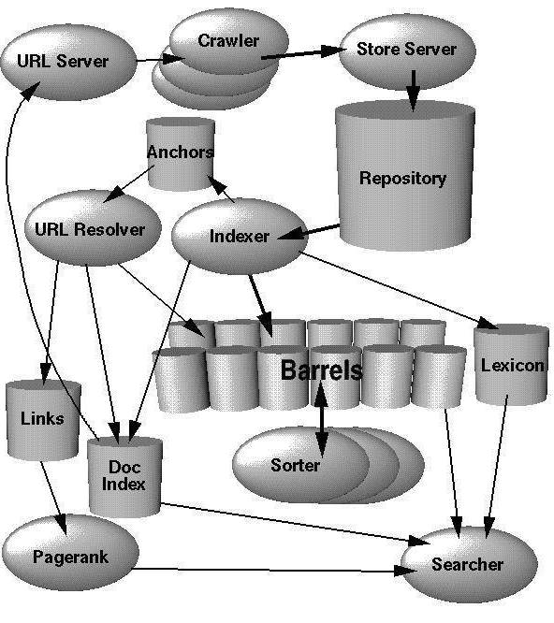

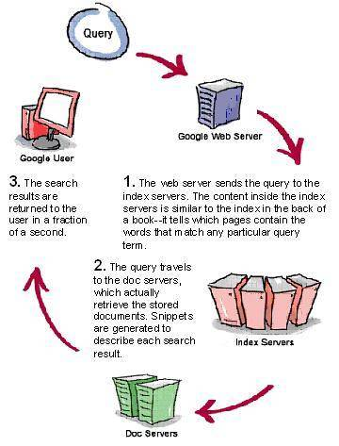

**AMAZON WEB SERVICES :**

Creating a software system is a lot like constructing a building. If the foundation is not solid, structural problems can undermine the integrity and function of the building. When architecting technology solutions on Amazon Web Services (AWS), if you neglect the five pillars of operational excellence, security, reliability, performance efficiency, and cost optimization, it can become challenging to build a system that delivers on your expectations and requirements.

1. **Operational Excellence** – The operational excellence pillar includes the ability to run and monitor systems to deliver business value and to continually improve supporting processes and procedures. You can find prescriptive guidance on implementation in the Operational Excellence Pillar whitepaper.
2. **Security** – The security pillar includes the ability to protect information, systems, and assets while delivering business value through risk assessments and mitigation strategies. You can find prescriptive guidance on implementation in the Security Pillar whitepaper.
3. **Reliability** – The reliability pillar includes the ability of a system to recover from infrastructure or service disruptions, dynamically acquire computing resources to meet demand, and mitigate disruptions such as misconfigurations or transient network issues. You can find prescriptive guidance on implementation in the Reliability Pillar whitepaper.
4. **Performance Efficiency** – The performance efficiency pillar includes the ability to use computing resources efficiently to meet system requirements and to maintain that efficiency as demand changes and technologies evolve. You can find prescriptive guidance on implementation in the Performance Efficiency Pillar whitepaper.
5. **Cost Optimization** – The cost optimization pillar includes the ability to avoid or eliminate unneeded cost or suboptimal resources. You can find prescriptive guidance on implementation in the Cost Optimization Pillar whitepaper.

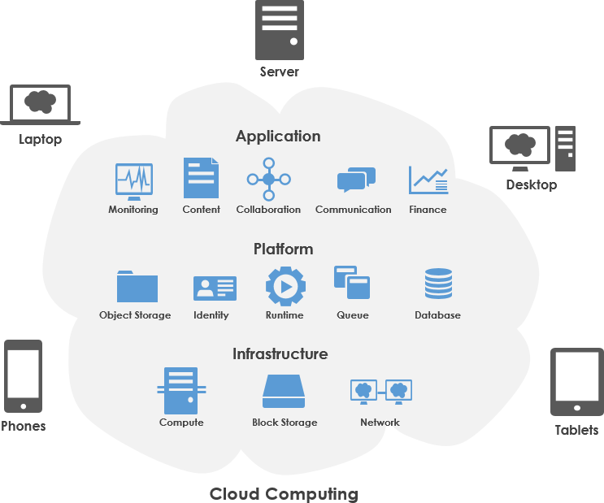

**Q.2 Create a simple website for a Car renting by using html, CSS, Java script, Bootstrap**

**and J query and perform following task:**

**1. Store data of Sign Up and car data in a XML file.**

**2. View user sign up data.**

**3. And view cars data on data Grid View.**

**FRONT END CODE**

**ADDCARS.ASPX**

<%@ Page Language="C#" AutoEventWireup="true" CodeBehind="AddCars.aspx.cs" Inherits="Rent_a_car_website.AddCars" %>

<!DOCTYPE html>

<html xmlns="http://www.w3.org/1999/xhtml">

<head runat="server">

<title></title>

<link href="scripts/css/bootstrap.css" rel="stylesheet" />

<style>

.navbar {

margin-bottom: 0;

border-radius: 0;

}

.jumbotron {

/* OR Image in the center top of the container */

background-position: center top;

background-image: url("images/erh.jpg");

}

</style>

</head>

<body>

<nav class="navbar navbar-inverse">

<div class="container-fluid">

<div class="navbar-header">

<a class="navbar-brand" href="#">Rent a car</a>

</div>

<ul class="nav navbar-nav">

<li><a href="Home.aspx">Home</a></li>

<li><a href="AddCars.aspx">Add cars</a></li>

<li><a href="ViewCars.aspx">View cars</a></li>

<li><a href="ViewUsers.aspx">View Users</a></li>

</ul>

<ul class="nav navbar-nav navbar-right">

<li><a href="Signup.aspx">Signup</a></li>

</ul>

</div>

</nav>

<div class="row centered-form">

<div class="col-xs-12 col-sm-8 col-md-4 col-sm-offset-2 col-md-offset-4">

<div class="panel panel-default">

<div class="panel-heading">

<h3 class="panel-title">Add car <small>It's free!</small></h3>

</div>

<div class="panel-body">

<form role="form" runat="server">

<div class="row">

<div class="col-xs-6 col-sm-6 col-md-6">

<div class="form-group">

<input runat="server" required type="text" name="Title" id="Title" class="form-control input-sm" placeholder="Title"/>

</div>

</div>

<div class="col-xs-6 col-sm-6 col-md-6">

<div class="form-group">

<input runat="server" type="text" required name="Carname" id="Carname" class="form-control input-sm" placeholder="Car name"/>

</div>

</div>

</div>

<div class="form-group">

<input runat="server" type="text" required name="model" id="model" class="form-control input-sm" placeholder="Model"/>

</div>

<div class="row">

<div class="col-xs-6 col-sm-6 col-md-6">

<div class="form-group">

<input runat="server" type="text" required name="Year" id="Year" class="form-control input-sm" placeholder="Year"/>

</div>

</div>

<div class="col-xs-6 col-sm-6 col-md-6">

<div class="form-group">

<select runat="server" name="city" id="city" title="Pick a number" class="form-control">

<option>Select...</option>

<option>Karachi</option>

<option>Lahore</option>

<option>islamabad</option>

</select>

</div>

</div>

</div>

<asp:Button ID="AddCar" class="btn btn-info btn-block" runat="server" Text="Add car" OnClick="AddCar_Click" />

</form>

</div>

</div>

</div>

</div>

<script src="scripts/js/jquery.js"></script>

<script src="scripts/js/bootstrap.js"></script>

</body>

</html>

**HOME.ASPX**

<%@ Page Language="C#" AutoEventWireup="true" CodeBehind="Home.aspx.cs" Inherits="Rent_a_car_website.Home" %>

<!DOCTYPE html>

<html xmlns="http://www.w3.org/1999/xhtml">

<head runat="server">

<link href="scripts/css/bootstrap.css" rel="stylesheet" />

<title></title>

<style>

.navbar {

margin-bottom: 0;

border-radius: 0;

}

.jumbotron{

/* OR Image in the center top of the container */

background-position: center top;

background-image: url("images/erh.jpg");

}

</style>

</head>

<body>

<nav class="navbar navbar-inverse">

<div class="container-fluid">

<div class="navbar-header">

<a class="navbar-brand" href="#">Rent a car</a>

</div>

<ul class="nav navbar-nav">

<li><a href="Home.aspx">Home</a></li>

<li><a href="AddCars.aspx">Add cars</a></li>

<li><a href="ViewCars.aspx">View cars</a></li>

<li><a href="ViewUsers.aspx">View Users</a></li>

</ul>

<ul class="nav navbar-nav navbar-right">

<li><a href="Signup.aspx">Signup</a></li>

</ul>

</div>

</nav>

<div class="row">

<form runat="server">

<div class="col-lg-12">

<img src="scripts/images/erh.jpg" class="img-responsive" alt="test">

<div class="carousel-caption">

<h1>Want to rent a car?</h1>

<button class="btn btn-lg btn-success">Rent a car !</button>

</div>

</div>

</form>

</div>

<script src="scripts/js/jquery.js"></script>

<script src="scripts/js/bootstrap.js"></script>

</body>

</html>

**SIGNUP.ASPX**

<%@ Page Language="C#" AutoEventWireup="true" CodeBehind="Signup.aspx.cs" Inherits="Rent_a_car_website.Signup" %>

<!DOCTYPE html>

<html xmlns="http://www.w3.org/1999/xhtml">

<head runat="server">

<title></title>

<link href="scripts/css/bootstrap.css" rel="stylesheet" />

<style>

.navbar {

margin-bottom: 0;

border-radius: 0;

}

.jumbotron{

/* OR Image in the center top of the container */

background-position: center top;

background-image: url("images/erh.jpg");

}

</style>

</head>

<body>

<nav class="navbar navbar-inverse">

<div class="container-fluid">

<div class="navbar-header">

<a class="navbar-brand" href="#">Rent a car</a>

</div>

<ul class="nav navbar-nav">

<li><a href="Home.aspx">Home</a></li>

<li><a href="AddCars.aspx">Add cars</a></li>

<li><a href="ViewCars.aspx">View cars</a></li>

<li><a href="ViewUsers.aspx">View Users</a></li>

</ul>

</div>

</nav>

<div class="row centered-form">

<div class="col-xs-12 col-sm-8 col-md-4 col-sm-offset-2 col-md-offset-4">

<div class="panel panel-default">

<div class="panel-heading">

<h3 class="panel-title">Please sign up for Car Rent <small>It's free!</small></h3>

</div>

<div class="panel-body">

<form role="form" runat="server">

<div class="row">

<div class="col-xs-6 col-sm-6 col-md-6">

<div class="form-group">

<input runat="server" type="text" name="first_name" id="first_name" class="form-control input-sm" required placeholder="First Name"/>

</div>

</div>

<div class="col-xs-6 col-sm-6 col-md-6">

<div class="form-group">

<input runat="server" type="text" name="last_name" id="last_name" class="form-control input-sm" required placeholder="Last Name"/>

</div>

</div>

</div>

<div class="form-group">

<input runat="server" type="email" name="email" id="email" class="form-control input-sm" required placeholder="Email Address"/>

</div>

<div class="row">

<div class="col-xs-6 col-sm-6 col-md-6">

<div class="form-group">

<input runat="server" type="password" name="password" id="password" class="form-control input-sm" required placeholder="Password"/>

</div>

</div>

<div class="col-xs-6 col-sm-6 col-md-6">

<div class="form-group">

<input runat="server" type="password" name="password_confirmation" id="password_confirmation" class="form-control input-sm" required placeholder="Confirm Password"/>

</div>

</div>

</div>

<asp:Button class="btn btn-info btn-block" ID="Button1" runat="server" Text="Signup" OnClick="Button1_Click" />

</form>

</div>

</div>

</div>

</div>

<script src="scripts/js/jquery.js"></script>

<script src="scripts/js/bootstrap.js"></script>

</body>

</html>

**VIEWCARS.ASPX**

<%@ Page Language="C#" AutoEventWireup="true" CodeBehind="ViewCars.aspx.cs" Inherits="Rent_a_car_website.ViewCars" %>

<!DOCTYPE html>

<html xmlns="http://www.w3.org/1999/xhtml">

<head runat="server">

<title></title>

<style>

.navbar {

margin-bottom: 0;

border-radius: 0;

}

.jumbotron{

/* OR Image in the center top of the container */

background-position: center top;

background-image: url("images/erh.jpg");

}

</style>

<link href="scripts/css/bootstrap.css" rel="stylesheet" />

</head>

<body>

<nav class="navbar navbar-inverse">

<div class="container-fluid">

<div class="navbar-header">

<a class="navbar-brand" href="#">Rent a car</a>

</div>

<ul class="nav navbar-nav">

<li><a href="Home.aspx">Home</a></li>

<li><a href="AddCars.aspx">Add cars</a></li>

<li><a href="ViewCars.aspx">View cars</a></li>

<li><a href="ViewUsers.aspx">View Users</a></li>

</ul>

<ul class="nav navbar-nav navbar-right">

<li><a href="Signup.aspx">Signup</a></li>

</ul>

</div>

</nav>

<div class="container">

<h2>Cars for rent</h2>

<p>The following cars are available for rent:</p>

<form runat="server">

<asp:GridView ID="GridView1" Width="600" runat="server">

</asp:GridView>

<asp:Button ID="Button1" class="btn btn-lg btn-success" runat="server" Text="View Users" OnClick="Button1_Click" />

</form>

</div>

<script src="scripts/js/jquery.js"></script>

<script src="scripts/js/bootstrap.js"></script>

</body>

</html>

**VIEWUSERS.ASPX**

<%@ Page Language="C#" AutoEventWireup="true" CodeBehind="ViewUsers.aspx.cs" Inherits="Rent_a_car_website.ViewUsers" %>

<!DOCTYPE html>

<html xmlns="http://www.w3.org/1999/xhtml">

<head runat="server">

<title></title>

<style>

.navbar {

margin-bottom: 0;

border-radius: 0;

}

.jumbotron{

/* OR Image in the center top of the container */

background-position: center top;

background-image: url("images/erh.jpg");

}

</style>

<link href="scripts/css/bootstrap.css" rel="stylesheet" />

</head>

<body>

<nav class="navbar navbar-inverse">

<div class="container-fluid">

<div class="navbar-header">

<a class="navbar-brand" href="#">Rent a car</a>

</div>

<ul class="nav navbar-nav">

<li><a href="Home.aspx">Home</a></li>

<li><a href="AddCars.aspx">Add cars</a></li>

<li><a href="ViewCars.aspx">View cars</a></li>

<li><a href="ViewUsers.aspx">View Users</a></li>

</ul>

<ul class="nav navbar-nav navbar-right">

<li><a href="Signup.aspx">Signup</a></li>

</ul>

</div>

</nav>

<div class="container">

<h2>Registered Users</h2>

<p>Following is the list of registered users:</p>

<form runat="server">

<asp:GridView ID="GridView1" Width="600" runat="server">

</asp:GridView>

<asp:Button class="btn btn-lg btn-success" ID="Button1" runat="server" Text="View Users" OnClick="Button1_Click" />

</form>

</div>

<script src="scripts/js/jquery.js"></script>

<script src="scripts/js/bootstrap.js"></script>

</body>

</html>

**FRONT END SNAPSHOTS**

**ADDCARS**

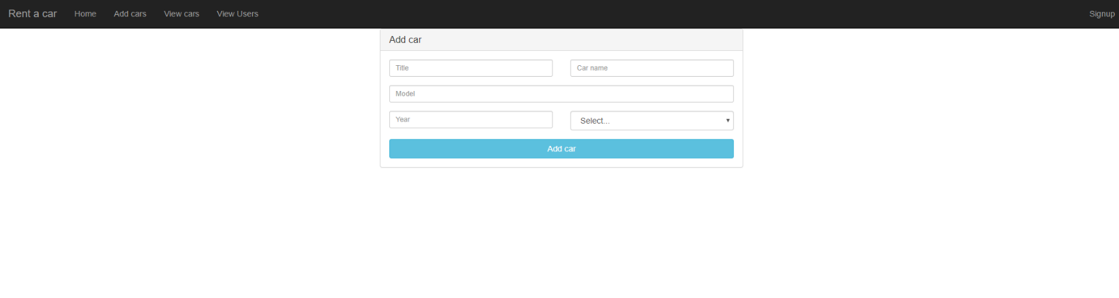

**HOME**



**SIGNUP**

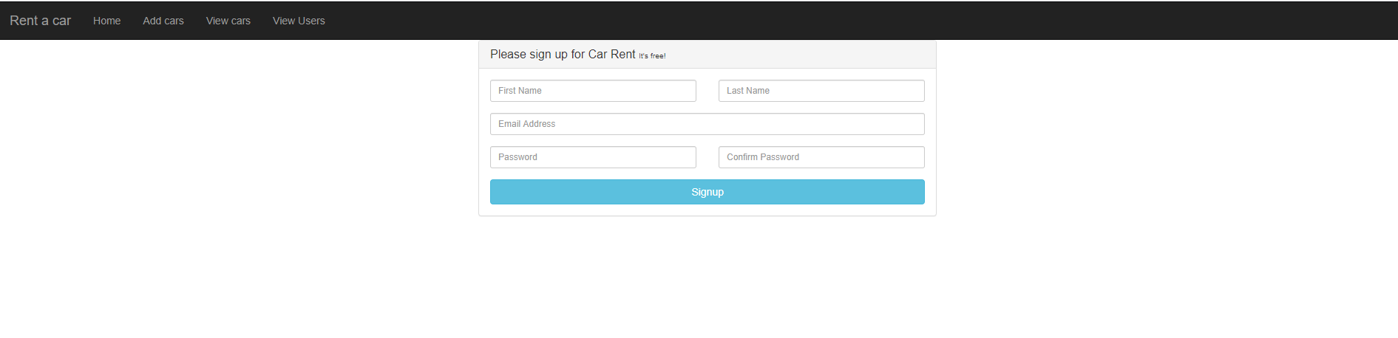

**VIEW CARS**

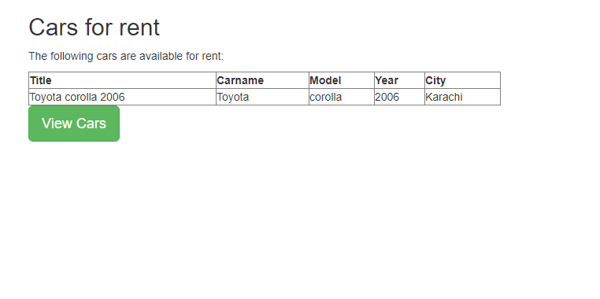

**VIEW USERS**

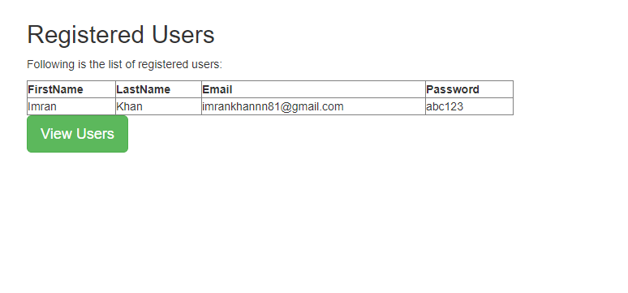

**BACKEND CODE**

**ADDCARS.ASPX.CS**

using System;

using System.Collections.Generic;

using System.IO;

using System.Linq;

using System.Web;

using System.Web.UI;

using System.Web.UI.WebControls;

using System.Xml;

using System.Xml.Linq;

namespace Rent_a_car_website

{

public partial class AddCars : System.Web.UI.Page

{

protected void Page_Load(object sender, EventArgs e)

{

}

protected void AddCar_Click(object sender, EventArgs e)

{

String title = Convert.ToString(Title.Value);

String carname = Convert.ToString(Carname.Value);

String model_no = Convert.ToString(model.Value);

String Year_no = Convert.ToString(Year.Value);

String mydropdown = Convert.ToString(city.Value);

if (!File.Exists("F:\\Cars.xml"))

{

XmlWriterSettings xmlWriterSettings = new XmlWriterSettings();

xmlWriterSettings.Indent = true;

xmlWriterSettings.NewLineOnAttributes = true;

using (XmlWriter xmlWriter = XmlWriter.Create("F:\\Cars.xml", xmlWriterSettings))

{

xmlWriter.WriteStartDocument();

xmlWriter.WriteStartElement("Cars");

xmlWriter.WriteStartElement("Record");

xmlWriter.WriteElementString("Title", title);

xmlWriter.WriteElementString("Carname", carname);

xmlWriter.WriteElementString("Model", model_no);

xmlWriter.WriteElementString("Year", Year_no);

xmlWriter.WriteElementString("City", mydropdown.ToString());

xmlWriter.WriteEndElement();

xmlWriter.WriteEndElement();

xmlWriter.WriteEndDocument();

xmlWriter.Flush();

xmlWriter.Close();

}

}

else

{

XDocument xDocument = XDocument.Load("F:\\Cars.xml");

XElement root = xDocument.Element("Cars");

IEnumerable<XElement> rows = root.Descendants("Record");

XElement firstRow = rows.First();

firstRow.AddBeforeSelf(

new XElement("Record",

new XElement("Title", title),

new XElement("Carname", carname),

new XElement("Model", model_no),

new XElement("Year", Year_no),

new XElement("City", mydropdown.ToString())));

xDocument.Save("F:\\Cars.xml");

}

}

}

}

**SIGNUP.ASPX.CS**

using System;

using System.Collections.Generic;

using System.IO;

using System.Linq;

using System.Web;

using System.Web.UI;

using System.Web.UI.WebControls;

using System.Xml;

using System.Xml.Linq;

namespace Rent_a_car_website

{

public partial class Signup : System.Web.UI.Page

{

protected void Page_Load(object sender, EventArgs e)

{

}

protected void Button1_Click(object sender, EventArgs e)

{

String fname= Convert.ToString(first_name.Value);

String lname = Convert.ToString(last_name.Value);

String em= Convert.ToString(email.Value);

String pwd= Convert.ToString(password.Value);

String pwdConf = Convert.ToString(password_confirmation.Value);

//string script = string.Format("alert('{0}');", fname+lname+em+pwd+pwdConf);

//Page page = HttpContext.Current.CurrentHandler as Page;

//if (page != null && !page.ClientScript.IsClientScriptBlockRegistered("alert"))

//{

// page.ClientScript.RegisterClientScriptBlock(page.GetType(), "alert", script, true /* addScriptTags */);

//}

if (!File.Exists("F:\\Users.xml"))

{

XmlWriterSettings xmlWriterSettings = new XmlWriterSettings();

xmlWriterSettings.Indent = true;

xmlWriterSettings.NewLineOnAttributes = true;

using (XmlWriter xmlWriter = XmlWriter.Create("F:\\Users.xml", xmlWriterSettings))

{

xmlWriter.WriteStartDocument();

xmlWriter.WriteStartElement("Users");

xmlWriter.WriteStartElement("Record");

xmlWriter.WriteElementString("FirstName", fname);

xmlWriter.WriteElementString("LastName", lname);

xmlWriter.WriteElementString("Email", em);

xmlWriter.WriteElementString("Password", pwd);

xmlWriter.WriteEndElement();

xmlWriter.WriteEndElement();

xmlWriter.WriteEndDocument();

xmlWriter.Flush();

xmlWriter.Close();

}

}

else

{

XDocument xDocument = XDocument.Load("F:\\Users.xml");

XElement root = xDocument.Element("Users");

IEnumerable<XElement> rows = root.Descendants("Record");

XElement firstRow = rows.First();

firstRow.AddBeforeSelf(

new XElement("Record",

new XElement("FirstName", fname),

new XElement("LastName", lname),

new XElement("Email", em),

new XElement("Password", pwd)));

xDocument.Save("F:\\Test.xml");

}

}

}

}

**VIEW CARS.ASPX.CS**

using System;

using System.Collections.Generic;

using System.Data;

using System.Linq;

using System.Web;

using System.Web.UI;

using System.Web.UI.WebControls;

namespace Rent_a_car_website

{

public partial class ViewCars : System.Web.UI.Page

{

protected void Page_Load(object sender, EventArgs e)

{

}

protected void Button1_Click(object sender, EventArgs e)

{

using (DataSet ds = new DataSet())

{

ds.ReadXml("F:\\Cars.xml");

//Assign the xml data to gridview

GridView1.DataSource = ds;

GridView1.DataBind();

}

}

}

}

**VIEW USERS.ASPX.CS**

using System;

using System.Collections.Generic;

using System.Data;

using System.Linq;

using System.Web;

using System.Web.UI;

using System.Web.UI.WebControls;

namespace Rent_a_car_website

{

public partial class ViewUsers : System.Web.UI.Page

{

protected void Page_Load(object sender, EventArgs e)

{

}

protected void Button1_Click(object sender, EventArgs e)

{

using (DataSet ds = new DataSet())

{

ds.ReadXml("F:\\Users.xml");

//Assign the xml data to gridview

GridView1.DataSource = ds;

GridView1.DataBind();

}

}

}

}

**XML FILES**

